Q)Write a SQL query to create a table to store the Employee data

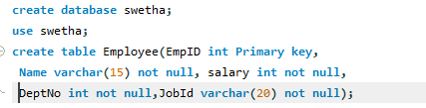

Q)Write a SQL query to insert the data into Employee table

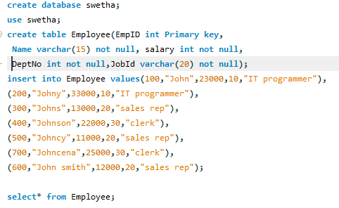

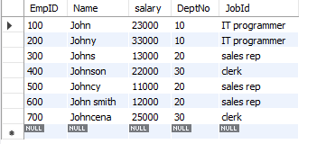

Q)Write a SQL query to increment the Salary by 1000 for the Employees of Department 20

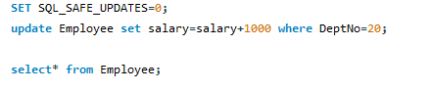

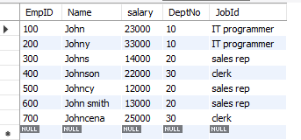

Q)Write a SQL query for displaying the Employee who earn Salary above 20000

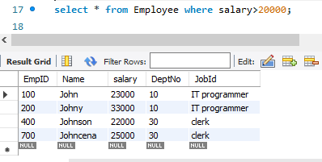

Q)Write a SQL query to the Employee count based on their Job ID



